Testthemodel

|  |  |
| --- | --- |
| Date | 24 November 2022 |
| TeamID | PNT2022TMID43214 |
| Project Name | AI-powered Nutrition Analyzer forFitnessEnthusiasts |

Evaluationisa processduringthedevelopment ofthemodel tocheck

whetherthe model is thebest fit for thegiven problem and corresponding

data.

Loadthesavedmodelusingload_model

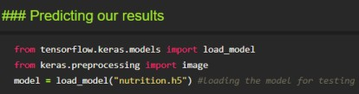

Takinganimageasinputandcheckingtheresults

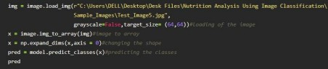

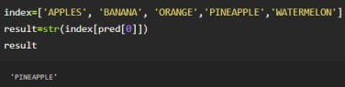Byusingthemodelwearepredictingtheoutputforthegiveninput image

The predicted class index name will be printed here.